中文安裝說明
How to install the Linksys Internet Video Camera

一、準備工作 preparing
● 必需要有IP分享器
This camera requires a router.
● 單純本地監視、錄影，並不需要有網路
Your camera doesn’t require an internet connection for local offline watching/recording.
● 一台P4等級以上的電腦，有網路卡用網路線連接IP分享器
The Linksys Internet Video Camera is compatible with processors that are P4(Pentium 4) or newer. Connect the PC to the router provided your PC has a network interface card.
★ 注意：網路攝影機必需先把網路線插好通路後，再插電運作。
Note:Camera has to be connected to the router before it is plugged into the power supply.

二、安裝網路攝影機 Install the Internet Camera
● 步驟一：先網路線接LAN
Step1 : Plug in the LAN dock with a cable.
步驟二：再插電源線到電源接口與插座
Step2: Plug in the power dock and the power supply.

● Ip分享器連接網路線到網路攝影機
Connect the router to the camera.
● 插上電腦
Connect to the computer.

三、電腦安裝軟體(在光碟片選WVC11B檔，安裝軟體)
Install the driver (select the WVC11B on the CD provided)
● 光碟片內選擇第二項 Install Viewer & Recorder Utility，點擊下一步安裝
Select the second ‘Install viewer & Record Utility’ option.

四、設定網路攝影機
1、 打開已安裝的Viewer & Recorder Utility (出現桌面捷徑)
Open the shortcut that was loaded to your desktop.

2、 按下「Find鍵」， 可以搜尋在本地的網路攝影機
Click ‘Find’ and it will begin searching for locally installed cameras.
3、 找到上述介面的網路攝影機可以看到資訊，右方有顯示 192.168.1.115 這個就是此網路攝影機的管理介面，打開IE 瀏覽器，在網址列打上 192.168.1.115
In the Find camera from LAN. On the right-hand side you will notice an IP address ‘192,168,1,115’. This is the responsible management for this camera. Open internet window and type the IP address.

4、 點選上方「Setup鍵」 進入網路攝影機的基本設定，彈出視窗填入，使用者名稱：admin 密碼：admin
Click the setup option and go to the basic setting, fill in the user named and the password in the pop-up window.
Default: user name: admin password: admin

5、 此頁面為主要的設定頁面
The following page is the main settings directory
． Camera Name(攝影機名稱)： 限用英文字命名，用來識別用的
English only, this is for distinguish cameras.
． Date(日期)： 月 日 年
mm/dd/yyyy
． Time(時間)： 小時 分鐘
hour/min
． Time Zone(時區)： 選擇 Taipei 台北
． Configuration Type： 選擇 Obtain Address Automatically(DHCP)
Choose Obtain Address Automatically(DHCP)

全部設定完後，按最下方「Apply鍵」
Click the 'Apply' after finishing all the settings.

6、 設定畫質
在「Image鍵」的選項可以設定畫質，設定完後 「Apply鍵」
Choose your pixel’s settings in the image option.

● 錄影一小時所需的容量
The capacity does the computer need for recording one hour.
320x240 Very High 430MB
320x240 High 344MB
320x240 Normal 129MB
320x240 Low 51.6MB
160x120 Very High 86MB
160x120 High 43MB
160x120 Normal 21.5MB
160x120 Low 10.75MB
160x120 Very Low 4.3MB

7、無線功能Wireless
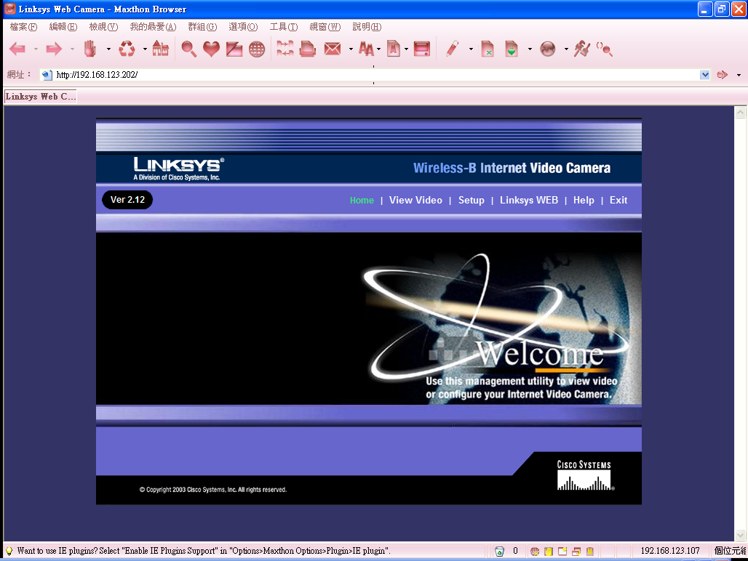
點setup進入設定頁面
Click the setup to the settings page.
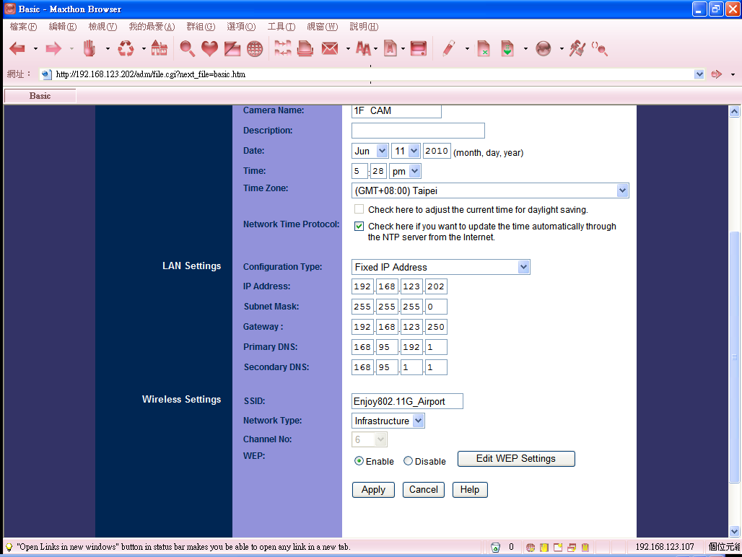
下方 Wireless Settings SSID (填上要連線基地台的無線名稱)
Wireless Setting SSID needs to be filled in the wireless named of the base station that you want to connect to.
Network Type 選擇 (Infrastructure)
Network Type choose Infrastructure.
WEP (如果你要連線的無線基地台有加密，請選擇 Enable)
WEP Choose the enable if the base station have been set passwords.
Edit WEP Settings (有加密的話 點選這裡填入密碼)
Edit WEP Setting Fill in your passwords here.
(基地台沒有加密的使用者 WEP 與 Edit WEP 可以跳過)
Skip the WEP and Edit WEP if the base station doesn't have passwords.

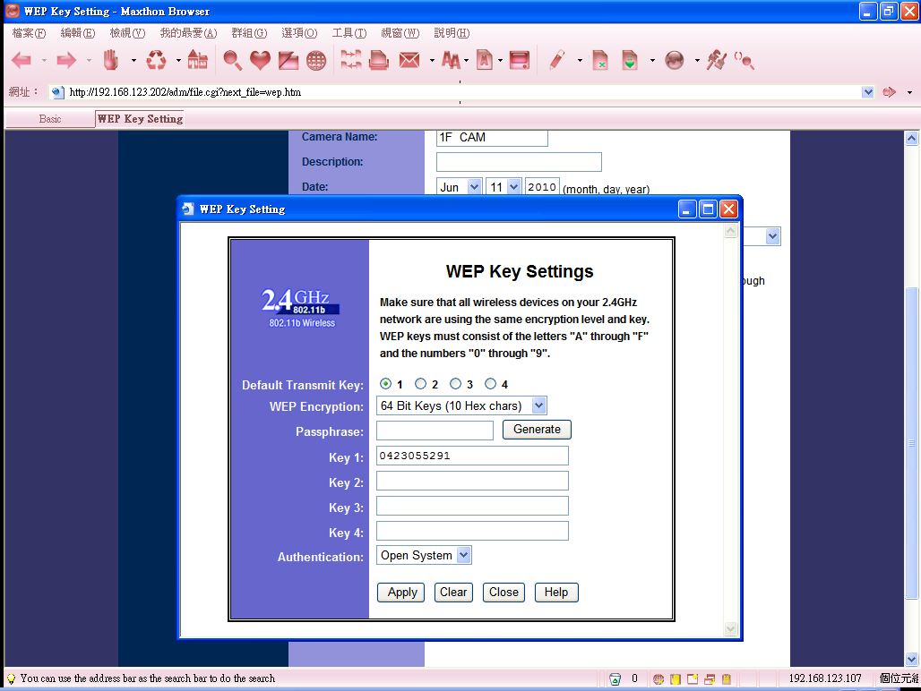
僅支援 WEP 64BIT 與 128BIT 加密
This encryption only for WEP 64bit and 128bit.
一般WEP加密 選擇 64Bit Keys
Choose the 64bit key if it is ordinary WEP encryption
在key 1 的欄位 填入你的無線基地台密碼 64bit 加密為 10碼數字
Fill in the passwords in the Key1, 64bit encryption will be 10 numbers.
按Apply 儲存 然後按Close 關閉這個頁面
Click 'Apply' to save, and close this page.
回到前一個畫面，按Apply 儲存網路攝影機的設定值。
Go back to the previous page and click the 'Apply' to save all the settings.
過約20秒後，請把攝影機的電源拔掉，攝影機的網路線也拔掉，插上電源後會自動連線到您所設定要連接的無線基地台。
Unplug the power supply and the cable from the camera after about 20 seconds,
replug the power supply then the camera will be connecting with the base station automatically.

五、管理網路攝影機與排程錄影
Manage the Internet camera and scheduling the recording
1、 打開已安裝的Viewer & Recorder Utility
Open the installed Viewer & Recorder Utility

按下「Find鍵」這時就會發現網路攝影機的名字，是已經變成你所設定的名稱，按「Add 鍵」加入到列表
Click the 'Find' then you will see the named of the camera which is set by yourself, click the 'Add' to add to the list.

2、 按「View鍵」瀏覽，在「View」視窗下可即時看狀況，錄影/停止
Click the 'View' to browse it, you can watch it immediately and recording/stop
3、 錄影配置
Recording settings
點選下方「Preferences 鍵」可以設定錄影的資料要放置在什麼地方，自訂路徑存放
You can choose the folder you want to put the recording data from the 'Preferences'.
4、 錄影排程
Scheduling the recording
下方的Schedule 可以編排錄影的時間，按下方「Add鍵」編排
You can also arrange the time you want to recording from the 'Schedule' and adjust the details from the 'Add'.

● 按下「Add鍵」會出現增加錄影介面：
The recording window will show up if you click the 'Add'.
． Camera ：選擇網路攝影機，此軟體可以支援多顆攝影鏡頭同時錄影，攝影鏡頭有命名的話，現在就很方便，可以選擇加入排程錄影。
Camera: Choose the internet cameras, this software supports multiple cameras recording at the same time.
． Frequency ：周期 Oen Time 單次，Everyday 每一天，每一個單日
． Start Date ：開始錄影的日期
． Start Time ：開始錄影的時間
． Duration (h/m)：錄多久的時間，小時：分鐘

「Save鍵」 完就完成了排程錄影了。
Click 'Save' to saving the schedule.

4、 播放錄影
Playing the recording videos.
點選「Files鍵」 進入播放介面
Go to the 'Files'.

點選要播放的錄影片段，按「Play鍵」就可以播放了。
Choose one that you want to play and click 'Play'.

